Status and changing patterns on coral reefs in Thailand during the last two decades
มีการอ้างอิงจำนวน 3 บทความ ดังนี้
1. https://journals.plos.org/plosone/article?id=10.1371/journal.pone.0343346
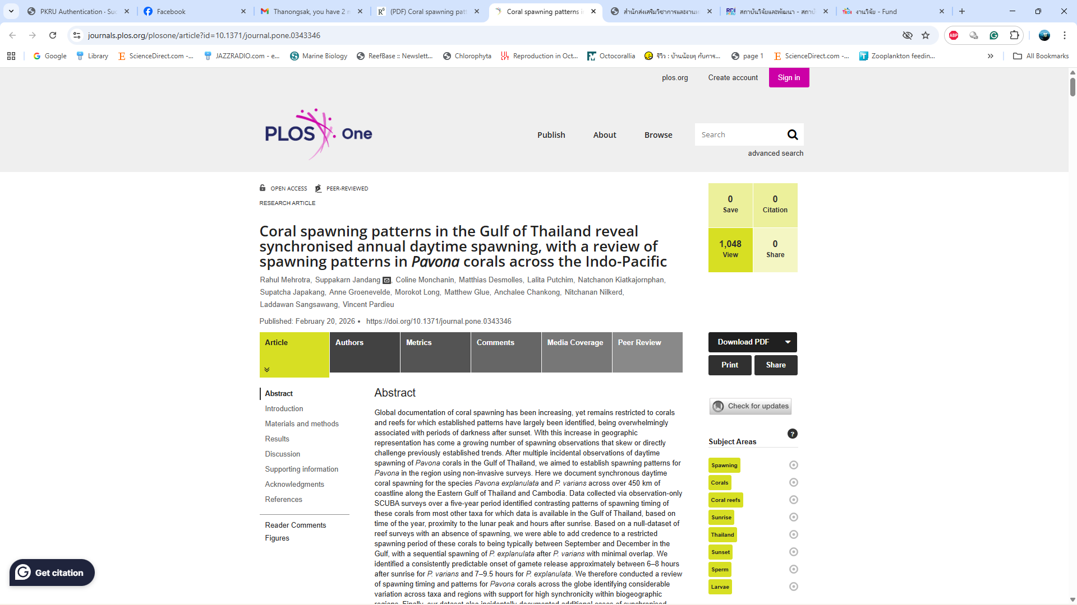
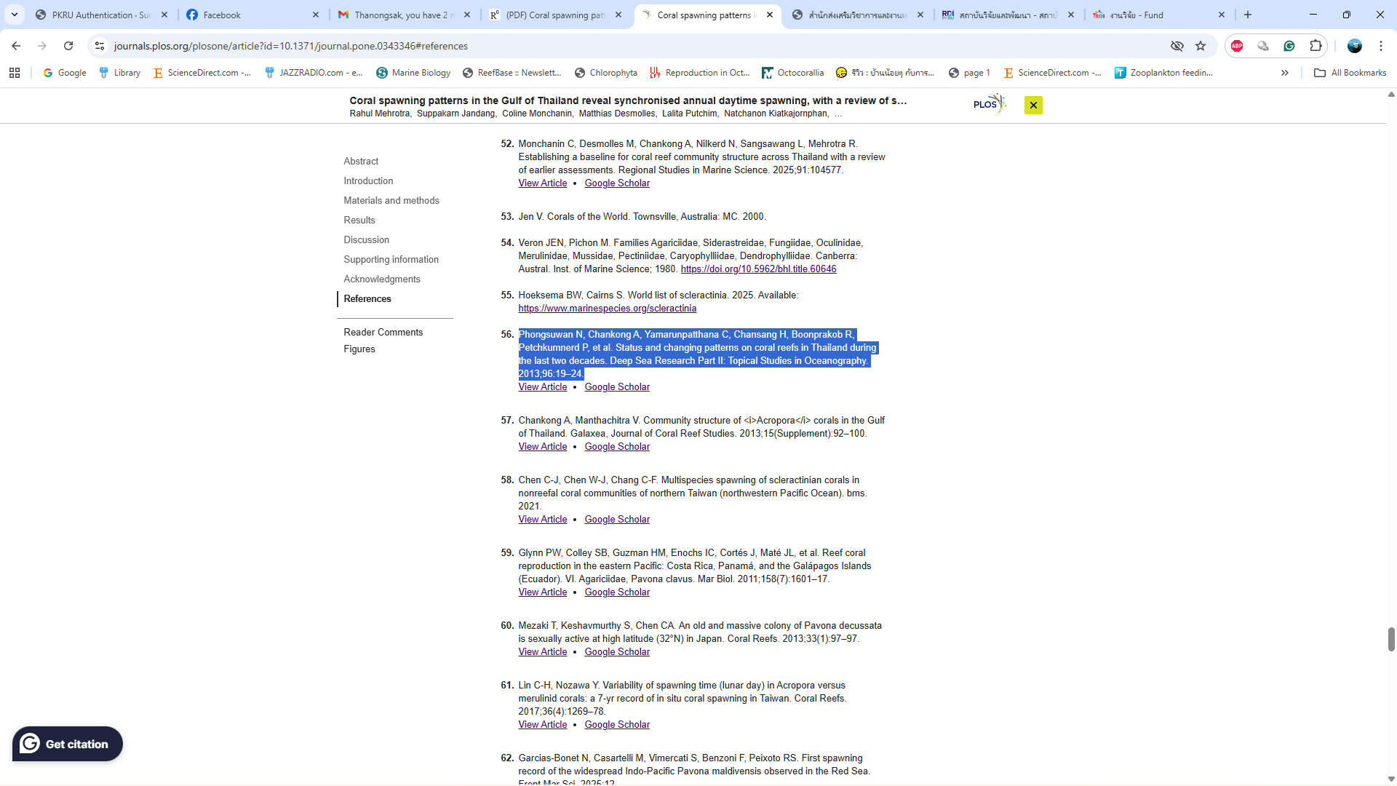

2. https://link.springer.com/article/10.1007/s00338-026-02823-0?utm_source=researchgate.net&utm_medium=article
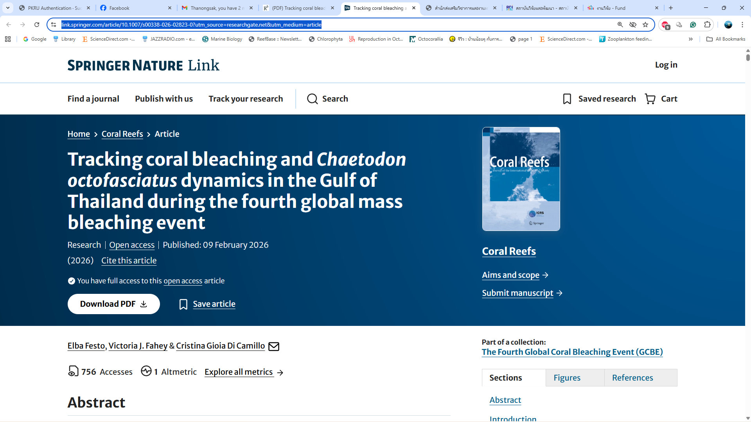
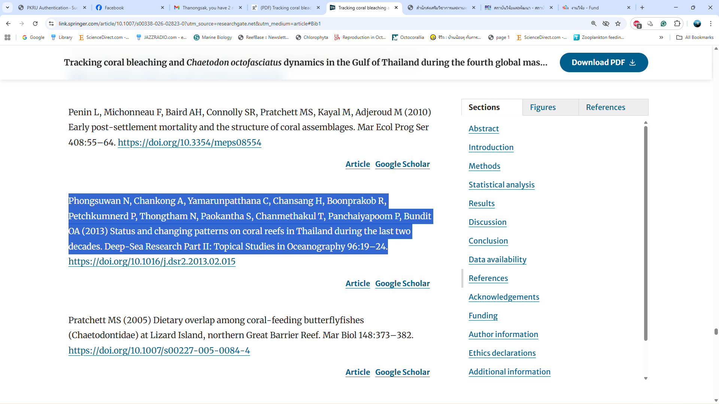

3. https://www.sciencedirect.com/science/article/abs/pii/S0272771425002999?via%3Dihub
