Assessment of Diversity of Culturable Marine Yeasts Associated with Corals and Zoanthids in the Gulf of Thailand, South China Sea
มีการอ้างอิงจำนวน 2 บทความ ดังนี้
1. https://enviromicro-journals.onlinelibrary.wiley.com/doi/10.1111/1758-2229.70212?utm_medium=article&utm_source=researchgate.net
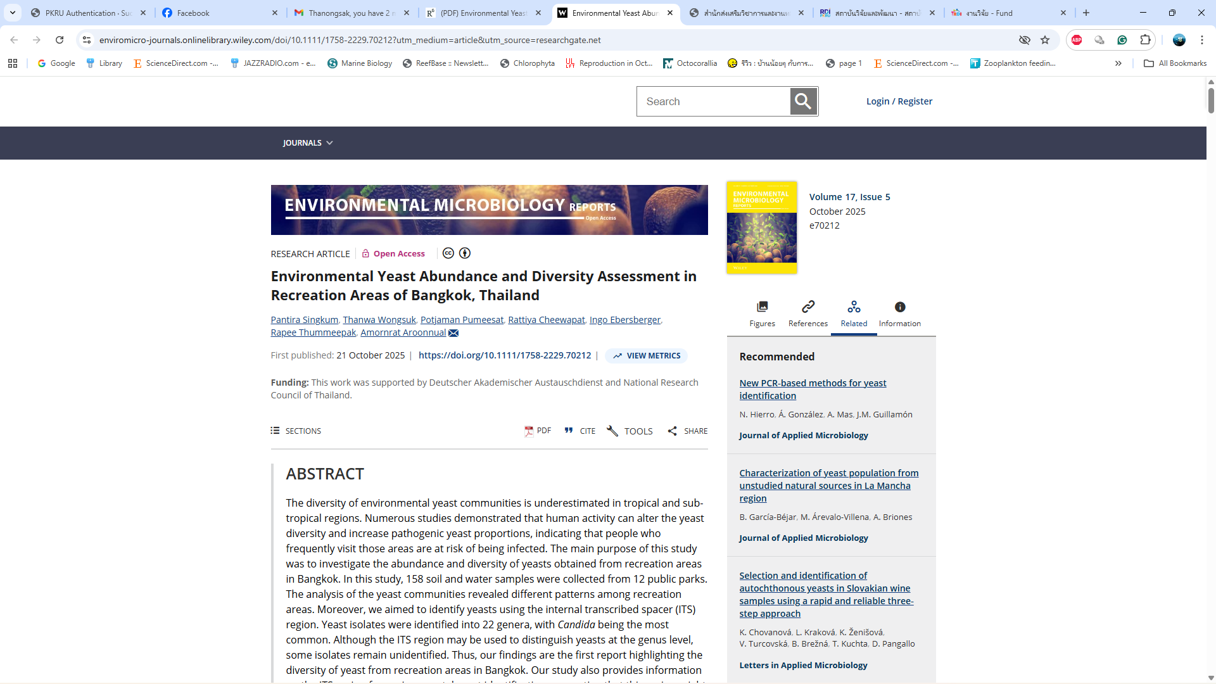
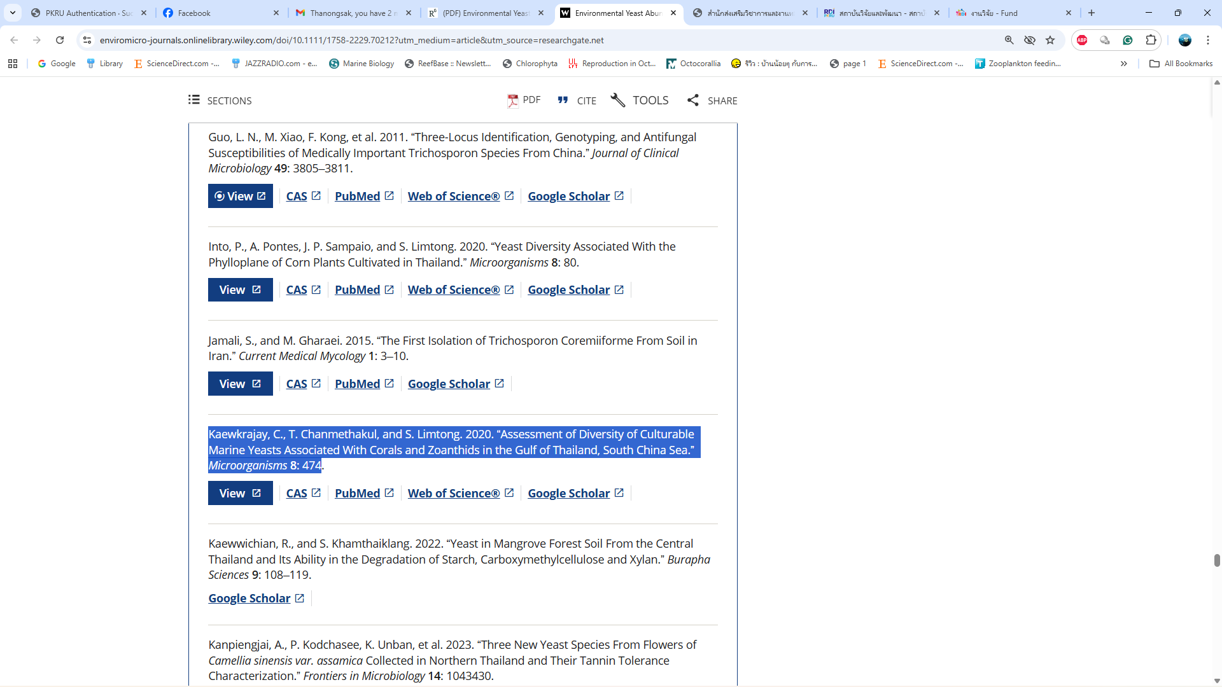

2. https://www.scielo.br/j/bjb/a/MsdzFXyhr96BM9JZ8x89M4d/?lang=en
