Developing and Evaluating a Program to Support Preparation for Aging: A Case Study from Phuket Province, Thailand
Chayanit Luevanich, Ros Kane https://orcid.org/0000-0002-6926-2530 rkane@lincoln.ac.uk, […], and Prapaipim Surachetkosom+1View all authors and affiliations
All Articles
https://doi.org/10.1177/23337214241280422

Citation ใน Future Care Planning for Ageing Adults With Intellectual Disabilities: Family Caregiver Perspectives in Thailand
Kanokporn Vibulpatanavong, Cheerapat Sirirak, Aporn Saardaium, Kamalaporn Sittichan
First published: 20 February 2026

https://doi.org/10.1111/jar.70204Digital Object Identifier (DOI)

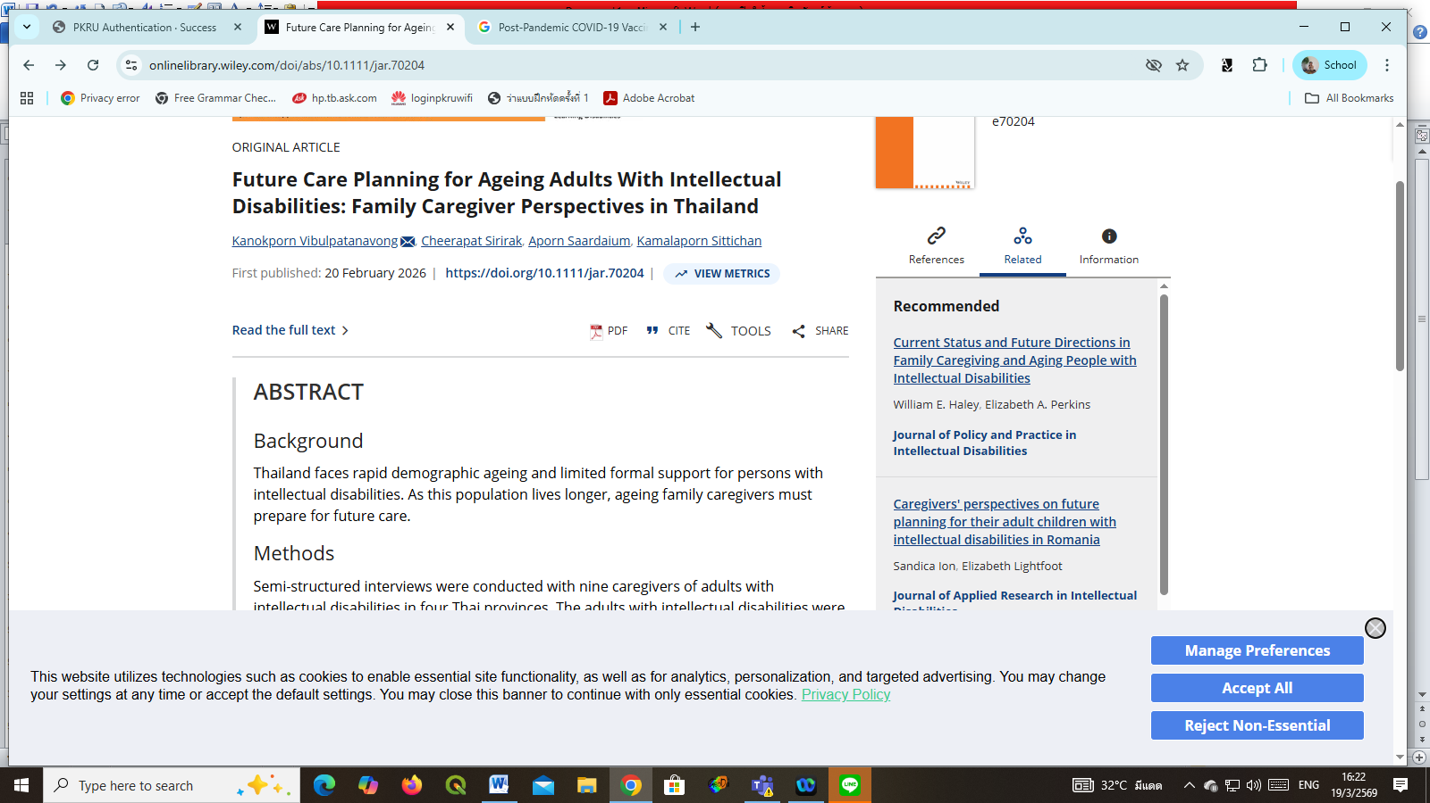

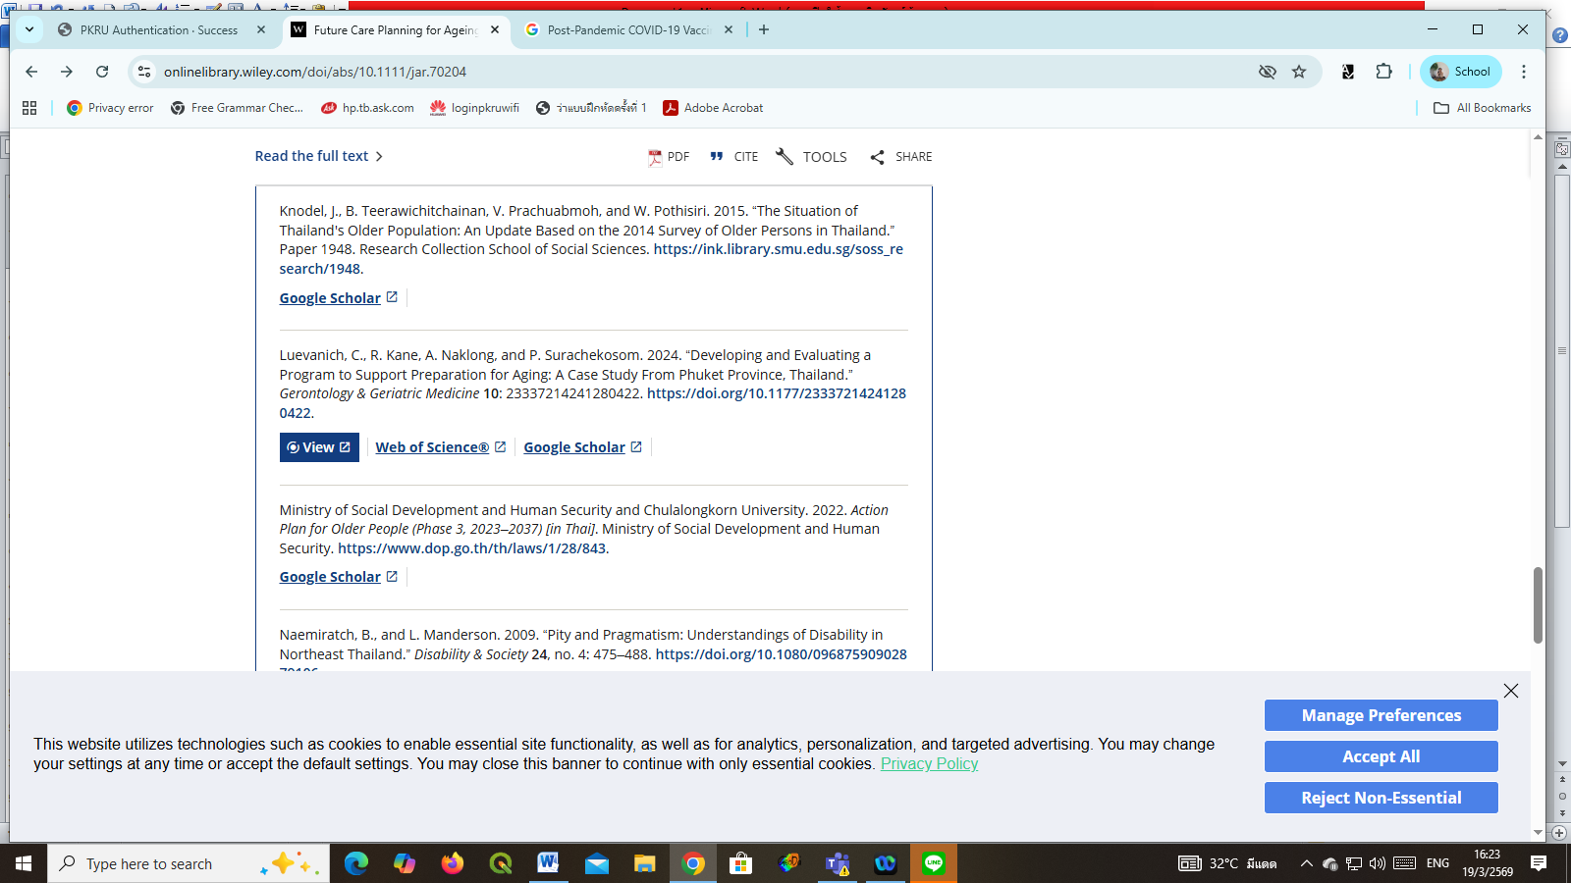

Citation in Preparar o Envelhecimento: A Adequação das Políticas e a Dignidade Individual – Uma revisão da literatura
Artigos
Publicado 12-12-2025

https://riagejournal.com/index.php/riage/article/view/403/497

