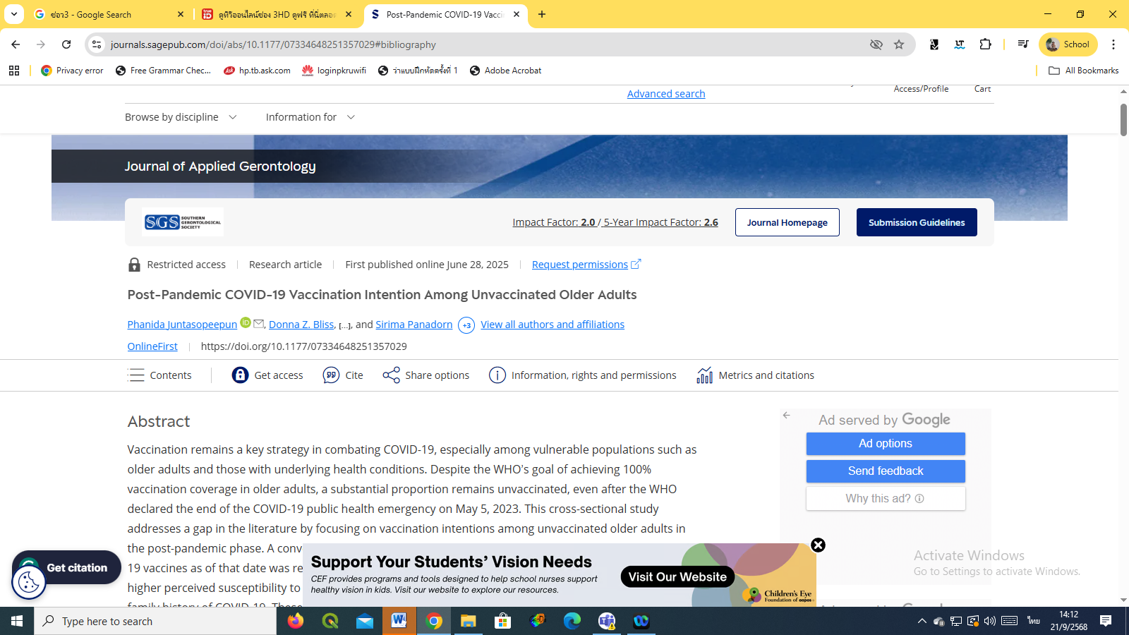

Post-Pandemic COVID-19 Vaccination Intention Among Unvaccinated Older Adults
Publish : June 2025



